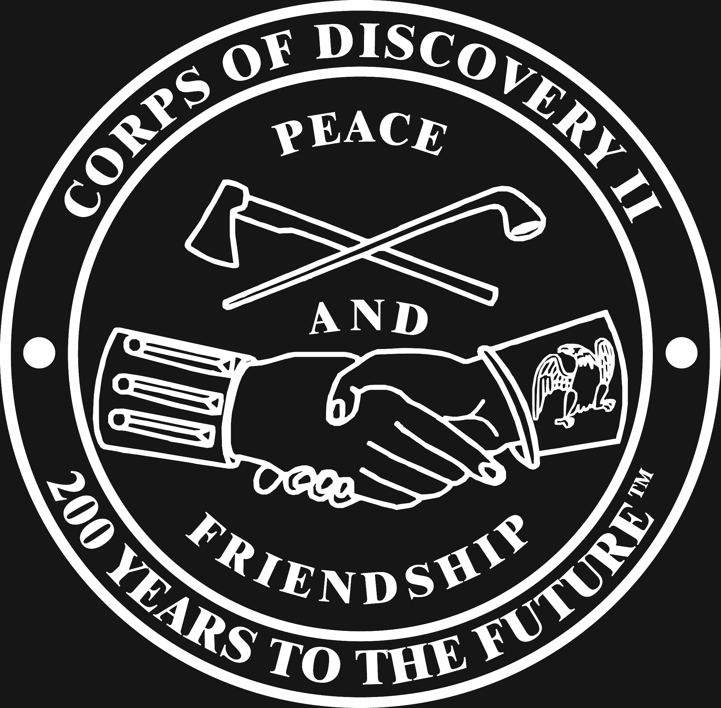
Corps of Discovery II
Lewis and Clark Traveling Exhibit

Panel 1

“We will find the shortest and most convenient route of communication between the United States and the Pacific Ocean.” With these words, Thomas Jefferson, third President of the United States, conceived of the greatest American adventure of all time.

Americans did not know what lay beyond the Mississippi River. Jefferson believed they would discover a land of volcanoes, llamas, even woolly mammoths, but most importantly he hoped they would discover a northwest passage to Asia.

Stop #2

President Jefferson chose his personal secretary, 29-year-old U.S. Army Captain Meriwether Lewis, to lead the expedition. “Your mission is to explore the Missouri River or any other river that may offer the most direct water communication across the continent.” Armed with Jefferson’s instructions, Captain Lewis stopped first at the new Federal Arsenal at Harpers Ferry (upper left) to collect arms and equipment (15 rifles, 24 pipe tomahawks, 15 large knives, 400 lbs. lead, 200 lbs. best rifle powder.)

Next, Lewis traveled to Philadelphia, the country’s largest city and a center for learning. Here, Jefferson arranged for Lewis to learn navigation, natural science, and basic medicine. Lewis purchased a sextant, a compass and a chronometer (upper right) and physician Benjamin Rush helped him assemble a medical kit. Prominent doctors and scientists schooled Captain Lewis on the techniques necessary to properly observe, report on, and take samples of the soils, animal, and plant life he would encounter. (Turn around and go to Stop #3)

Stop #3

If Jefferson’s plan was to succeed, Meriwether Lewis needed help. He turned to his trusted friend and fellow army officer, William Clark. “If there is anything in this enterprise, which would induce you to participate with me in its fatigues, its dangers and its honors…,” wrote Lewis. Red-haired, 33-year-old Clark replied, “I will cheerfully join you…”

Clark was the perfect choice. His family of Virginia adventurers had helped settle Kentucky. William’s five older brothers, all soldiers - including Revolutionary War hero George Rogers Clark - taught young William grit and self-reliance. In addition, William Clark was a talented mapmaker. When he left St. Louis, the maps he carried were filled with speculation (lower right). Two years later, Clark used his journals, with accurate observations and measurements, to create the masterpiece you see before you. It is a remarkably accurate rendering for its time. (Turn around and go to Stop #4)

Stop #4

But they would need help. It was time to assemble a team. Their “Corps of Discovery” was a well-organized and disciplined military operation. “I want good hunters, stout, healthy, unmarried men, accustomed to the woods, and capable of bearing bodily fatigue in a considerable degree.”- Lewis. The team picked nine of “the best young woodsmen and hunters” in Kentucky.

On August 31, 1803, Lewis launched the expedition in Pittsburgh (you can follow on the map). On a large, 50 foot keelboat built specially for the voyage, Lewis, along with his dog Seaman and several recruits, headed down the Ohio River. A month and a half later, Clark joined the expedition from his home near Louisville, Kentucky. Clark also brought along his slave, York, whom he had known his childhood. York was the only non-voluntary member of the expedition (upper right).

Rounding the bend at the mouth of the Ohio River, the tiny convoy inched its way against the current of the mighty Mississippi. U.S. regulars, infantry and artillerymen stepped forward at local forts and outposts to volunteer for the mission. By December, the group had reached the outskirts of St. Louis. Too late in the year to begin the trip west, the Corps established a winter barracks at Wood River (present-day Illinois), a 400-acre site across from the mouth of the Missouri River.

As Captain Lewis gathered more supplies from nearby St. Louis traders, he also recruited civilian “engages” (French river boatmen) to serve as guides and interpreters and to help move the vessels upriver. Now totaling one keelboat and two pirogue canoes, each was filled to the brim for the long journey ahead. (Go to Stop #5 on the right)

Stop #5

In late spring 1804, the Corps began to work its way up the Missouri River (follow the map). 600 miles later, they encountered Indian tribes. Following well-rehearsed speeches, the leaders presented peace medals to tribal members and made exchanges of trade goods like cloth and beads. But there were also military parades and displays of firepower as they spoke of their great “Chief” in Washington.

During that busy first summer, the expedition lost its first and only Corps member, Sgt. Charles Floyd, who died of natural causes - possibly the result of a burst appendix.

As the weather turned colder, the Corps reached the thriving trade center of the Mandan and Hidatsa villages in present-day North Dakota. The men constructed log cabins to form a winter quarters they christened Ft. Mandan. A French trader, Toussaint Charbonneau, stumbled upon the group while trading with the Mandan. Accompanied by his young Shoshone wife, Sacagawea, he was hired as an interpreter, a valuable skill as the Corps would need to trade for horses and other supplies on their long journey west. Sacagawea, 16 years old and pregnant, would prove invaluable to the success of the expedition. Later that winter, she gave birth to a son, named Jean Baptiste.

As the ice in the river began to melt, the expedition decided to split into two groups. One would continue on to the Pacific. The other group, manning the keelboat that was too cumbersome for the shallower waters, would head back downriver to St. Louis, loaded with journal reports, plant and animal specimens destined for Washington. (Turn around and cross to Stop #6)

Stop #6

The Corps of Discovery was now 31 hard-edged men with Sacagawea and her baby. The fleet of 6 dugout canoes and 2 pirogues started up the Missouri using routes the Indian tribes had been traveling for centuries (follow the map). By June, the Corps reached the Great Falls of the Missouri and endured an incredible overland trek around the Falls, pulling their boats and supplies on handmade carts. By late August, the expedition finally crossed paths with the local Shoshone people from whom Lewis hoped to obtain much-needed horses. An official council was held and translations proved slow and confusing from English to French to Mandan to Shoshone and back again. Then, in a scene of amazing coincidence, Sacagawea recognized and embraced the Shoshone Chief, Cameahwait, - her long-lost brother. The Corps soon had the horses and supplies they needed to cross the mountains.

Crossing the Continental Divide was no easy task and the expedition struggled to find its way through the snow-covered Bitterroot Mountains. After two weeks of hard travel with little food, the starving Corps reached the other side. Nez Perce Chief Twisted Hair welcomed and fed the strangers. The Corps gathered strength and carved out new canoes in which they continued on down the Snake River to the Columbia River meeting many more tribes along the way.

“Great joy in camp, we are in view of the Ocean…but still cold and wet, our clothes and bedding rotten…” – William Clark

As it was now late in the fall, the men constructed a 50-foot square stockade which they named Fort Clatsop after a local tribe (left of map). For three dull and rainy months, the Corps busied themselves hunting, making salt and performing daily drills. Their leaders spent many hours making sketches, maps and journal entries. By March 1806, the expedition set out again, facing a 4,000-mile return trip.

After separating to explore different water routes on the return, the two captains reunited in August to head down the Missouri river. On September 23, 1806, Lewis and Clark and the Corps of Discovery returned to St. Louis after a journey of more than two years and almost 8,000 miles.

A year later, Meriwether Lewis (far right) proudly posed, sporting his ermine mantle, “the most elegant piece of Indian dress I ever saw.” The mantle was a gift from Cameahwait, Sacagawea’s Shoshone brother. (Go to stops #7 and #8 on both sides ahead)

Stop #7

As the Corps began their journey up the Missouri River in the spring of 1805, Captain Lewis was eager to explore the land that lay ahead. Jefferson had instructed Lewis to make careful scientific observations of the plant and animal life. “We are about to penetrate a country at least 2,000 miles in width. I could esteem this moment as among the most happy of my life. I ascended to the top of the bluff this morning, from whence I had the most delightful view of the country, exposing to the first glance of the spectator immense herds feeding in one common and boundless pasture.”

The Corps passed through the arid Missouri Breaks and the “Stone Walls” (to the left). Spectacular sights greeted the explorers at every bend of the river. “The river has trickled down the soft sand cliffs and worn it into a thousand grotesque figures, elegant ranges of lofty freestone buildings, having their parapets well stocked with statuary.” – Lewis

Stop #8

Though the expedition did not reveal a northwest passage, it did find a diverse landscape, rich with unlimited potential for the new nation’s westward growth. Today, the vast uncharted area mapped by Captain Clark, is home to many who have followed to ranch, mine, log and farm the land. Remembering the bounty that existed 200 years ago, we must be thoughtful of the future and our role in shaping it. (Go to the bison herd at Stop #9 on your right)

Stop #9

“The whole face of the country was covered with herds of buffalo, elk and antelopes; deer are also abundant,…gangs of big-horned animals are on the face of the steep bluffs…[they] bound from rock to rock in the most careless manner.” – Lewis

Lewis and Clark were the first white explorers on the upper Missouri. Following their mission instructions, they drew and described many birds, mammals, insects and plants. They observed 122 animals and 178 plants that were new to science.

The Corps marksmen shot many different animals for food and specimens to send east. Indian dogs and bison tongues were considered especially good eating. “Discovered a large brown bear and six went to attack him, all good hunters…two of them reserved their fire. The four others fired at nearly the same time and put each his bullet through him. In an instant this monster ran at them with open mouth. They struck him several times again…he pursued two of them so close that they were obliged to throw themselves into the river. So enraged was this animal that he plunged into the river when one of those who still remained on shore shot him through the head and finally killed him…” – Lewis
(Go to the bison hunt at Stop #10)

Stop #10

The bison hunt was a ritual of life and death for the Indians of the Great Plains. Religious ceremonies, food, clothing, tools, fuel and shelter, all depended on the bison. When the herds were nearby, the whole village mobilized for the hunt. “Surround” hunts (upper right) rounded up and killed the huge animals. Carcasses were butchered on the spot. Villagers celebrated the bison’s gift and everyone, including the dogs, ate their fill. Every part of the bison was used to support the portable lifestyle of the tribe. Nothing was wasted.

The horse was a recent Spanish arrival that Plains and Plateau Indians quickly put into useful service. Indians became among the best mounted cavalry in the world, boldly darting among two-ton bulls, nimbly changing direction at breakneck speed. The white man’s firearms were useless after a single shot. The Indian hunters preferred their lances and bows, shooting arrows one after another right through the midsection of a running buffalo.

“Today we passed…the remains of…many carcasses of buffalo which had been driven over a precipice of 120 feet by the Indians and perished. In this manner the Indians of the Missouri destroy vast herds of buffalo at a stroke.” – Lewis

The Plains Indians had elaborate rituals to guarantee successful hunts. A sacred sign, the skull of a bison secured to a pile of rocks, was offered to the spirit of the herds that sustained the tribes year after year (lower right). (Go next to Stop #11 on the right)

Stop #11

Imagine a lonely windswept plain stretching as far as the eye can see. Suddenly, the silence is broken by the sounds of dogs, horses and hundreds of families pulling their belongings behind them. Within hours, a lively village takes form amid a sea of grass.

Each tipi lodge could shelter two families. Preparing the dozen or so hides needed for a lodge was a woman’s most important task. Once completed, it belonged to her alone. Women faced hard work, erecting and taking down lodges, making clothing and tools and preparing the meals. The men, respected hunters, warriors and leaders, protected the village. Inside a laced up lodge, the family had a comfortable, if somewhat smoky, sanctuary during bone-chilling winters.

In the summer of 1804, the Corps of Discovery had little diplomatic success with the migratory tribes in the Missouri Valley. The formal speeches and displays of firepower and gifts from a “Great Father” in the east were all met with doubt and uncertainty. The Corps met its greatest challenge from the Teton Sioux who seemed determined to stop their progress upstream. Teton Chiefs Black Buffalo and his rival The Partisan vied for control of trade along the river and with the tribes to the north. Without an interpreter and little to offer that impressed the tribes, Lewis and Clark faced a puzzling three-day confrontation. After a tense standoff, Black Buffalo finally intervened and allowed the Corps to continue upriver. (Turn around and go to the Mandan earth lodge at Stop #12)

Stop #12

The corn, bison and the Missouri River itself were life sources for the Mandan, Hidatsa and Arikara villages on the upper Missouri. The tribes hunted the bison but chose to live in permanent lodges made of wood and packed earth. As many as 16 people lived in each sturdy structure. Families often socialized on the roofs, and they were cozy during the fierce winters on the northern plains. All possessions were kept inside - cookware, food, storage vessels, decorations, dogs - even serving as a stable for horses (center). In the evenings, the tribes’ history came alive in the stories of the grandfathers and grandmothers. Each tribe had distinct stories of their creation and adventures of their cultural heroes.

The Corps of Discovery wintered here during their trip west. They were well-received and traded frequently with their hosts for essential foodstuffs. The Indians were astonished at the material wealth of the men, but were especially intrigued by Clark’s slave, York. The villagers had never seen a black man and they marveled at his strength. People wondered if his color might rub off.

Corn and trade goods from both east and west made this place the most important frontier crossroads of the upper Missouri. Their simple, but effective, “bull” boat - a single bison hide stretched over a flexible willow frame - gave them access to both sides of a wide river (far right). One of the five villages was recorded by native artist, Sitting Rabbit, at the time of Lewis and Clark’s 1804 visit (middle left). These villages were nearly as large as St. Louis and humming with life in 1804. Sadly, they were devastated by smallpox within a generation. (Go to Stop #13 on your right)

Stop #13

Among the American Indians, all things have spirits that are related one to the other. The entire world, connected to a Creator, is a spiritually active landscape where humans are but a part. Great natural landmarks are sacred places of visions and blessings. Strong, brave and wise animals like the bison, bear and eagle are respected as being an important part of the cycle of life. Scaffolds were once raised to honor the dead (on your left). The unbroken circle of bison and human skulls, dwarfed by the vast landscape, were comforting reminders of the unbroken ties between the living and the dead.

Wherever Lewis and Clark went, their hosts began important meetings with a pipe and great ceremony honoring the importance of that which was to be spoken. “Chief Cameahwait now presented the pipe to me…but when I reached…to receive it, he drew it back and repeated the ceremony three times, after which he pointed the stem first to the heavens then to the center of the magic circle, smoked himself with three whiffs and held the pipe until I took as many as I thought proper…” – Lewis. (Turn around and go to the canoes at Stop #14)

Stop #14

In the fall of 1805, the expedition was determined to reach the sea. West of the Rockies, down the Clearwater, Snake and Columbia Rivers, they traveled with the current instead of against it. Guided by the Nez Perce, the Corps rode the fierce rapids in their hollowed out canoes. As the party risked life and limb, surprised Indians lined the river banks. Palouse, Walla Walla, Umatilla, Yakama, Wishram and Wasco watched the strange flotilla pass their lands. Unable to speak the native tongue, the captains used sign language and the presence of Sacagawea to convey their peaceful intent. “The wife of Charbonneau, our interpreter, we find, reconciles all the Indians.” – Clark

The abundant waters provided the northwest Indians with vast quantities of salmon just as the Great Plains provided the tribes living there with bountiful bison. During the annual salmon migrations, the fish were speared and caught in nets at the falls of the Columbia River (bottom left). Dried on racks in the sun, the salmon were the source of a thriving trade that reached far into the interior of the continent.

Further downriver, the Corps met Chinook Indians, accomplished seafarers with large, well-crafted canoes. “Some of the larger canoes are fifty feet long and hold five tons or thirty people…They are waxed and painted and ornamented with curious images at the bow and stern…We could not but view with admiration the wonderful dexterity with which they guide their canoes over the boisterous seas…” – Lewis. (Go to Stop #15)

Stop #15

The kindness of the Clatsop and Chinook saved the desperate Americans when they arrived in November of 1805 and built Fort Clatsop. “They are a mild and inoffensive people…very loquacious and inquisitive, they possess good memories… The greatest harmony appears to exist among them. They are great hagglers of trade…articles which are vended by the whites at the entrance of the Columbia River, find their way to the most distant nations inhabiting its water.” – Lewis.

The nations had some customs that were surprising to the Americans. The portrait of a Chinook woman (left center top), shows her distinct profile. As an infant, her forehead had been pressed between boards for up to a year. The resulting flattened forehead was a sign of status to her tribe.

Lewis and Clark found much to admire in the Clatsop and Chinook cultures. Women voiced their opinions freely and tribesmen relied upon their judgment. The Indians’ cedar-plank houses were distinctive and well-crafted. Sometimes 20 feet wide and 60 feet long, they had rooms for several large families. “The woodwork and sculpture of these people as well as their hats and their waterproof baskets evince an ingenuity by no means common among the Aborigines of America.” – Lewis. (Go to the final Stop #16 near the entrance desk)

Stop #16

Captains Lewis and Clark, with their fellow adventurers, did not find the hoped-for Northwest Passage. What they did find, however, was a land of incredible natural and cultural wealth – the envy of the world.

Meriwether Lewis lived only a few years beyond his great adventure. He never wrote a promising book, but he and his companions left a legacy of journal entries that remain gripping, intelligent reading after two hundred years. Lewis’s partner, William Clark, lived a full life. His accurate mapping of a large piece of the American continent remains a crowning achievement.

For the native tribes, the Presidential Peace Medals handed out across the west promised a hand extended in peace and friendship. The reality proved less kind. As the Corps of Discovery returned to St. Louis, they were met by Americans already heading west to claim a land and a destiny that would forever alter the lives of the native peoples.

Hidatsa Chief, Black Moccasin (bottom right), met the Corps of Discovery in 1804. He was over 100 years old in this 1832 portrait.

In 1901, the 110-year-old face of a Nez Perce woman who clearly remembered seeing Lewis and Clark, bore all the hardships of time and life among a proud people.

What, in the end, was accomplished by the Corps of Discovery? Their expedition, exploring the Louisiana Purchase and beyond, fed the imagination of a young nation bound for the western horizon. The new land almost doubled the size of the United States. Its added resources are an incalculable treasure. Today, it is difficult to imagine an America without the spirit of the brave young men who explored it and the Indian cultures that still call it home.

(The End)

